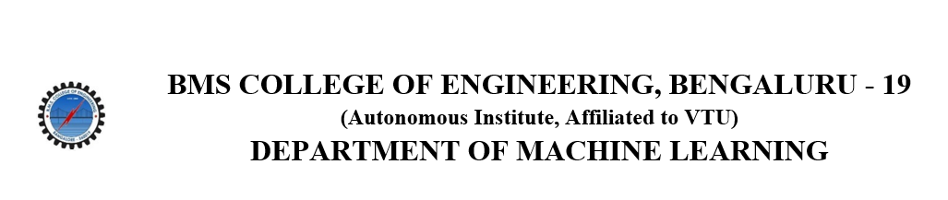

**ACTIVITY REPORT**

**ON**

**iTeach**

1. **Name of the Club:** BMSCE ACM STUDENT CHAPTER
2. **Name of the Activity:** iTeach
3. **Objectives:** BMSCE ACM Student Chapter conducted the CS Pathshala program as part of iTeach, an initiative by the BMS Rotaract Club. This collaboration brought a fresh technical perspective to the event, introducing students to key computational thinking concepts and fostering problem-solving skills in a creative and hands-on manner.
4. **Date, Time Venue of the Activity:**

| **EVENT** | iTeach |
| --- | --- |
| **DATE/DAY** | Wednesday, 15th January 2025 |
| **TIME** | 2:00 pm to 3:30 pm |
| **VENUE** | Vidya Vinayaka Samsthe, Bengaluru |

1. **Name and details of collaborating agency (if it is collaborative/joint activity):** BMSCE Rotaract Club
2. **Brief summary of the Event:**

The CS Pathshala program by the ACM India Council, conducted by the BMSCE ACM Student Chapter, was integrated into the iTeach initiative by the BMSCE Rotaract Club. This partnership focused on introducing computational thinking to students through dynamic, grade-specific activities that emphasized problem-solving, logical reasoning, and teamwork. Below is an overview of the activities conducted for each grade:

**Grades 1 & 2: Pattern and Logical Thinking**

* **Pattern Parade:** Students from **Grade 1** solved simple patterns using coloured blocks, while **Grade 2** created their own patterns for their peers to solve, enhancing their understanding of **sequencing** and **categorization.**
* **Sorting Station:** **Grade 1** students categorized objects based on a single characteristic (e.g., colour), while **Grade 2** worked with two characteristics (e.g., red squares vs. blue circles), reinforcing their **logical thinking** and **sorting abilities.**

**Grades 3 & 4: Step-by-Step Instructions, Loops, and Decision-Making**

* **Battleship-style Game:** The event included a creative game where Grade 3 students followed basic navigation steps, while Grade 4 students applied **loops for efficiency** and **flowchart logic** for smarter decision-making.

**Grades 5 & 6: Problem Decomposition and Data Representation**

* **Treasure Hunt with Coordinates:** Students worked in teams to find "treasures" using **coordinates**. Grade 5 students identified treasures using **single coordinates**, while Grade 6 students solved riddles for the next clue.

**Grade 7: Advanced Algorithms and Programming Concepts**

* **Algorithm Race:** Students wrote **step-by-step algorithms** to create a paper airplane. They tested and **debugged** their instructions, learning the importance of clear instructions and iterative improvement.
* **Nested Conditions Game:** Students used real-life problem scenarios to create decision trees, learning about **"if-else" conditions** and **logical thinking**.

This **iTeach** initiative helped foster **computational thinking** at various levels, from basic pattern recognition to more advanced algorithmic concepts, providing both volunteers and students a chance to **develop** essential **problem-solving skills**.

1. **Outcomes:** The CS Pathshala program by the ACM India Council introduced computational thinking to young learners through engaging activities. Collaborating with the iTeach initiative by BMSCE Rotaract Club, the event combined technical education with personal growth. Volunteers honed skills like communication and teamwork while fostering critical thinking and problem-solving among students.
2. **Number of participants:**

| **Number of Volunteers** | **Number of Students** |
| --- | --- |
| 7 | 100 |

1. **Photographs of the event:**

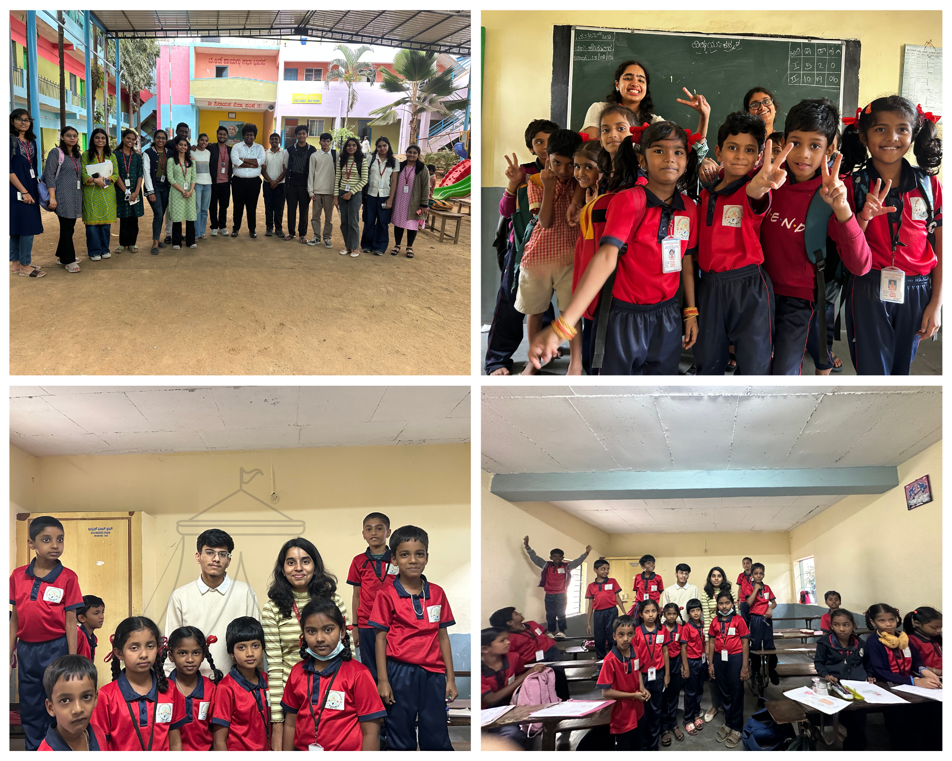

1. **Supporting Documents:**

**a.** **Circulars/Brochures/Posters:**

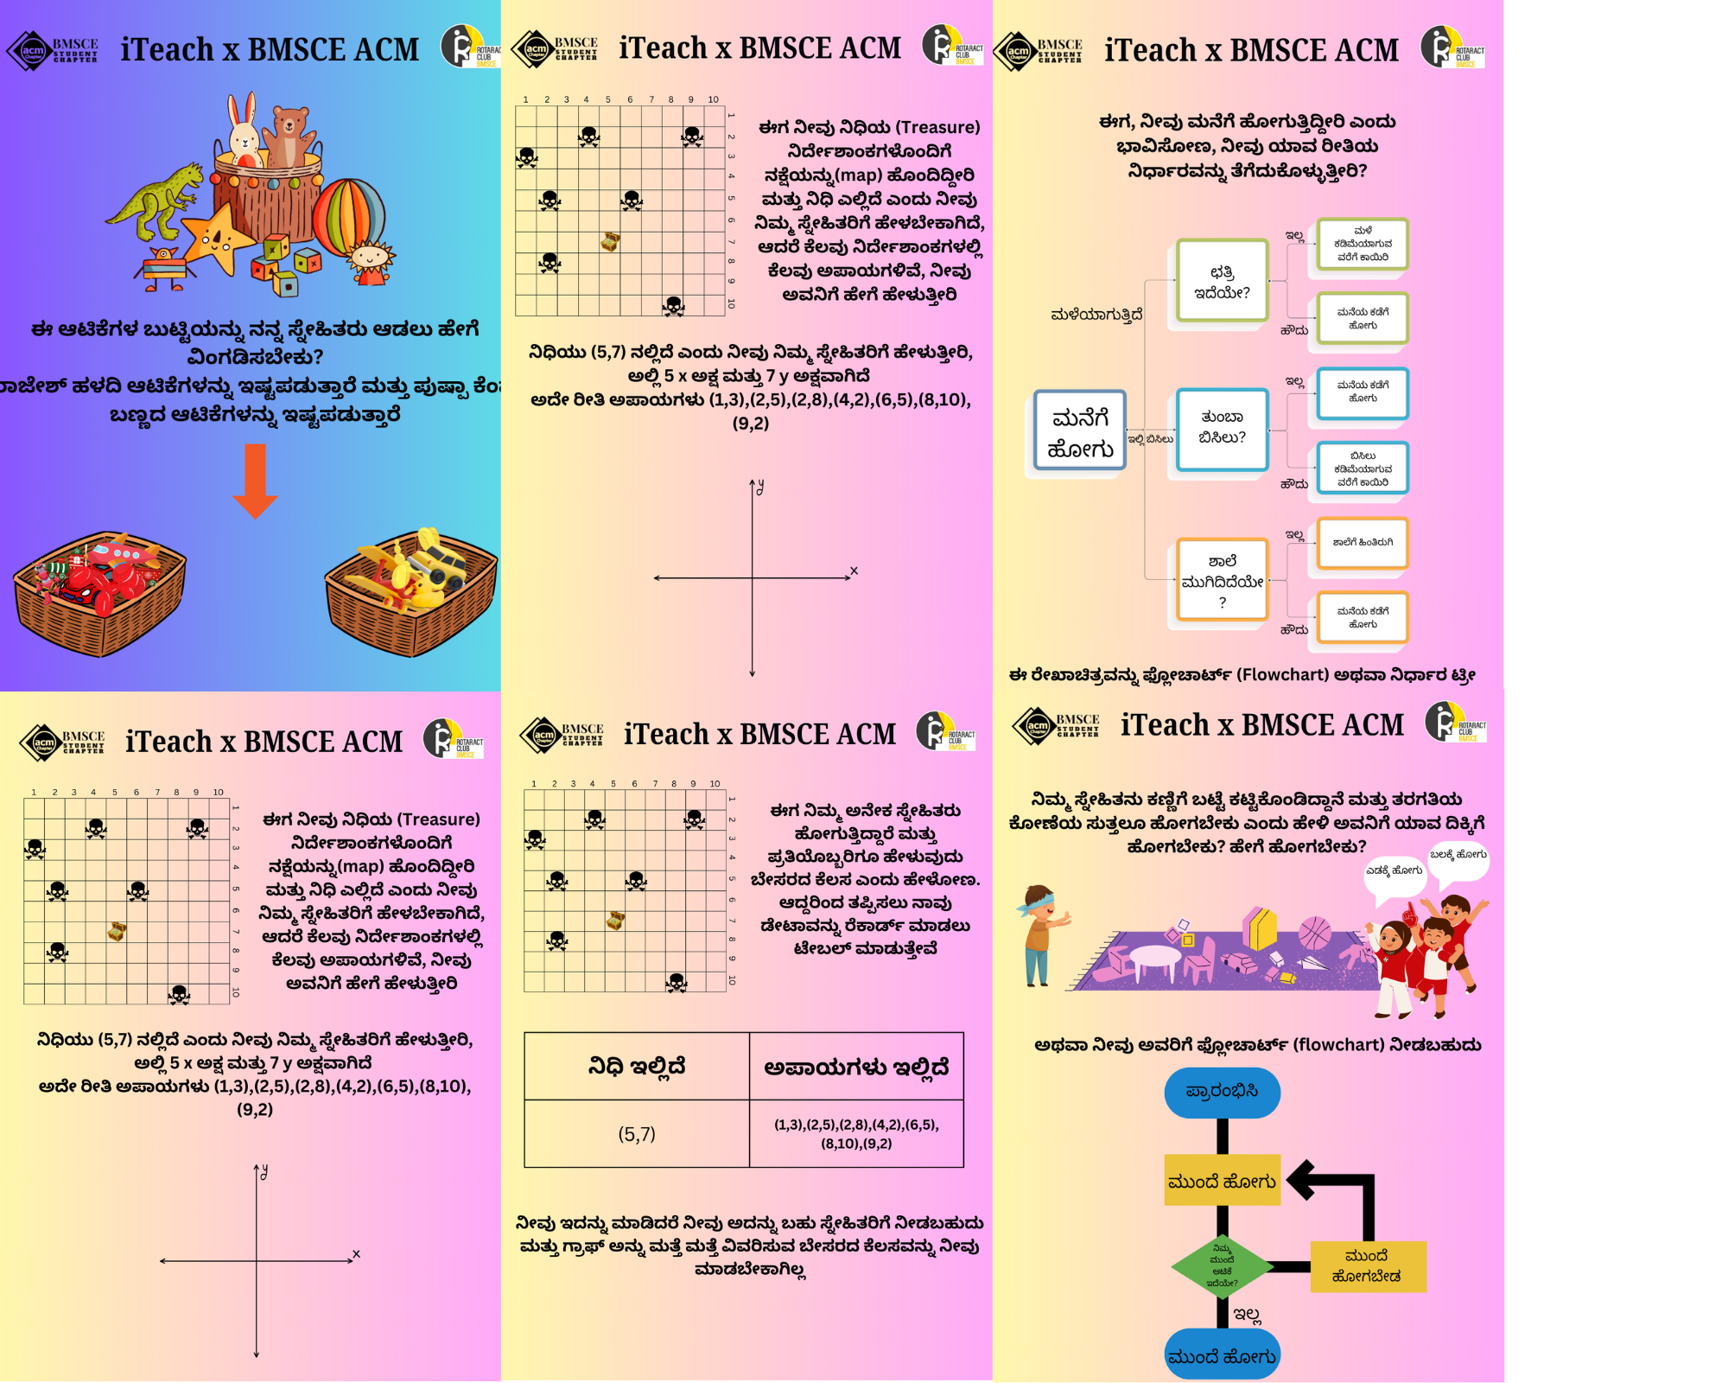

**b.** **Attendance Sheet:  
  
  
  
  
  
c. Certificates:**